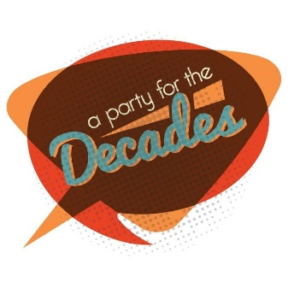

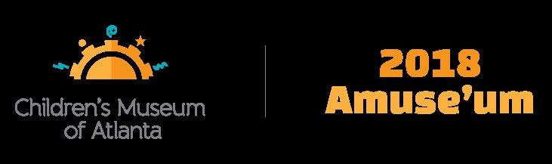

CONTACT:
Becca Meyer/Jennifer Walker
BRAVE PR, 404.233.3993
bmeyer@bravepublicrelations.com/
jwalker@bravepublicrelations.com

FOR IMMEDIATE RELEASE

Children’s Museum of Atlanta raises $270,000 at 15th annual Amuse’um event
Attendee contributions aid in the Museum’s mission of supporting early childhood education programming and community outreach

ATLANTA (March 21, 2018) – A groovy crowd celebrated Children’s Museum of Atlanta to the max during the 15th annual Amuse’um fundraiser held on Saturday, March 3! The signature benefit, themed “A Party for the Decades,” raised $270,000 to support the Museum’s early childhood education programming and community outreach initiatives though ticket sales; sponsorships; and live and silent auctions. Co-chairs Emily Graney and Elizabeth Kuney led a spectacular evening to honor the Museum’s longtime friends and supporters Molly and John Jamieson.

“It was quite the treat to be able to ring in the Museum’s 15th birthday with our closest friends and supporters,” said Jane Turner, executive director of Children’s Museum of Atlanta. “It’s through their donations and ongoing support that we’re able to cement our position as the only Atlanta educational venue that provides this type of educational programming for young minds.”

Presented by Georgia Natural Gas, the “A Party for the Decades” theme offered guests a far out variety of activities, entertainment and cuisine from the 1950s-1990s! Guests posed for photos with iconic stars from the twentieth century, indulged in a candy buffet, grooved to greatest hits, explored Museum exhibits, celebrated the Museum’s birthday with cake, divulged a password to enter the speakeasy, enjoyed hand-crafted cocktails — and more! The festivities also included live entertainment featuring break dancers, a cappella singers, a boyband cover group, a fundraising game that gave a new meaning to “heads or tails” and raffles as well as live and silent auctions.

The live auction featured a luxurious getaway to The Residences at Grand Luxxe resort in Nuevo Vallarta, Mexico; tickets to the 2018 Macy’s Thanksgiving Day Parade and opportunity to meet with the parade’s creative director; two tickets to see “Hamilton” at Richard Rogers Theatre in New York City; and the ultimate Atlanta United experience to see four home games, a behind-the-scenes tour of Mercedes Benz Stadium and autographed jersey. Silent auction highlights included local getaways, restaurant gift cards, admission to area-attractions and more.

All proceeds support the Children’s Museum of Atlanta’s early childhood educational programming and community outreach that touches the lives of more than 200,000 local children and families annually. Serving the children, families and schools in Atlanta and throughout Georgia, the Museum has welcomed more than 2.7 million visitors since opening in 2003.

About Children’s Museum of Atlanta:
Children’s Museum of Atlanta is the only educational venue of its kind in Atlanta, presenting educational programs and exhibits designed for young children ages 0-8. The Museum’s mission is to spark imagination and inspire discovery and learning for all children through the power of play. With six permanent learning zones consisting of bright, creative and hands-on exhibits, the Museum supports inventive play-based exploration and experiential learning focused on the whole child. Core competencies for literacy, math and science are promoted throughout all exhibits and programming in alignment with the state and national Core Performance Standards. The Children’s Museum of Atlanta also offers parties, memberships, field trips, summer camp and private events. For more information or to support Children's Museum of Atlanta, visit childrensmuseumatlanta.org or call 404.659.KIDS [5437].

###

